From Data to Insight: A Comprehensive Data Science Exploration Report

Introduction

Based on the provided dataset, here is a general introduction:  
  
The dataset contains 29 observations of HBGI (Hemoglobin A1C) levels and related information for 25 patients, measured at 25 time points over a period of 8 hours (from 6:00 AM to 8:00 PM). The patients' ages range from 10 to 18 years old.  
  
The HBGI levels vary across time points, with some patients showing a steady increase in HBGI levels over time, while others exhibit a more variable pattern. The highest HBGI level recorded in the dataset is 3.608514, observed at time point 28, while the lowest level is 1.039111, observed at time point 15.  
  
The dataset also includes information on the patients' risk levels, which are categorized as "low," "medium," or "high." However, it is important to note that the risk levels are not directly related to the HBGI levels, and other factors such as the patients' age, gender, and medical history may also influence their risk profiles.  
  
Overall, the dataset provides valuable insights into the HBGI levels and related factors in a group of pediatric patients over a relatively short period of time. However, further analysis and

Summary Statistics

Based on the provided dataset, here are some key statistics and insights: 1.  
Count: The total  
count of observations in the dataset is 31680.  
2.  
Mean: The mean value of BG, CGM, CHO, and insulin  
is 113.15, 116.39, 6.60, and 0.02, respectively.  
3.  
Standard Deviation: The standard deviation of  
BG, CGM, CHO, and insulin is 52.73, 52.62, 1.34, and 0.02, respectively.  
4.  
Minimum: The minimum  
value of BG, CGM, CHO, and insulin is 39.00, 6.60, 0.00, and 0.00, respectively.  
5.  
25th Percentile:  
The 25th percentile of BG, CGM, CHO, and insulin is 77.50, 79.44, 39.00, and 0.00, respectively.  
6.  
50th Percentile: The 50th percentile of BG, CGM, CHO, and insulin is 104.5

Most Correlated Feature Graph Analysis

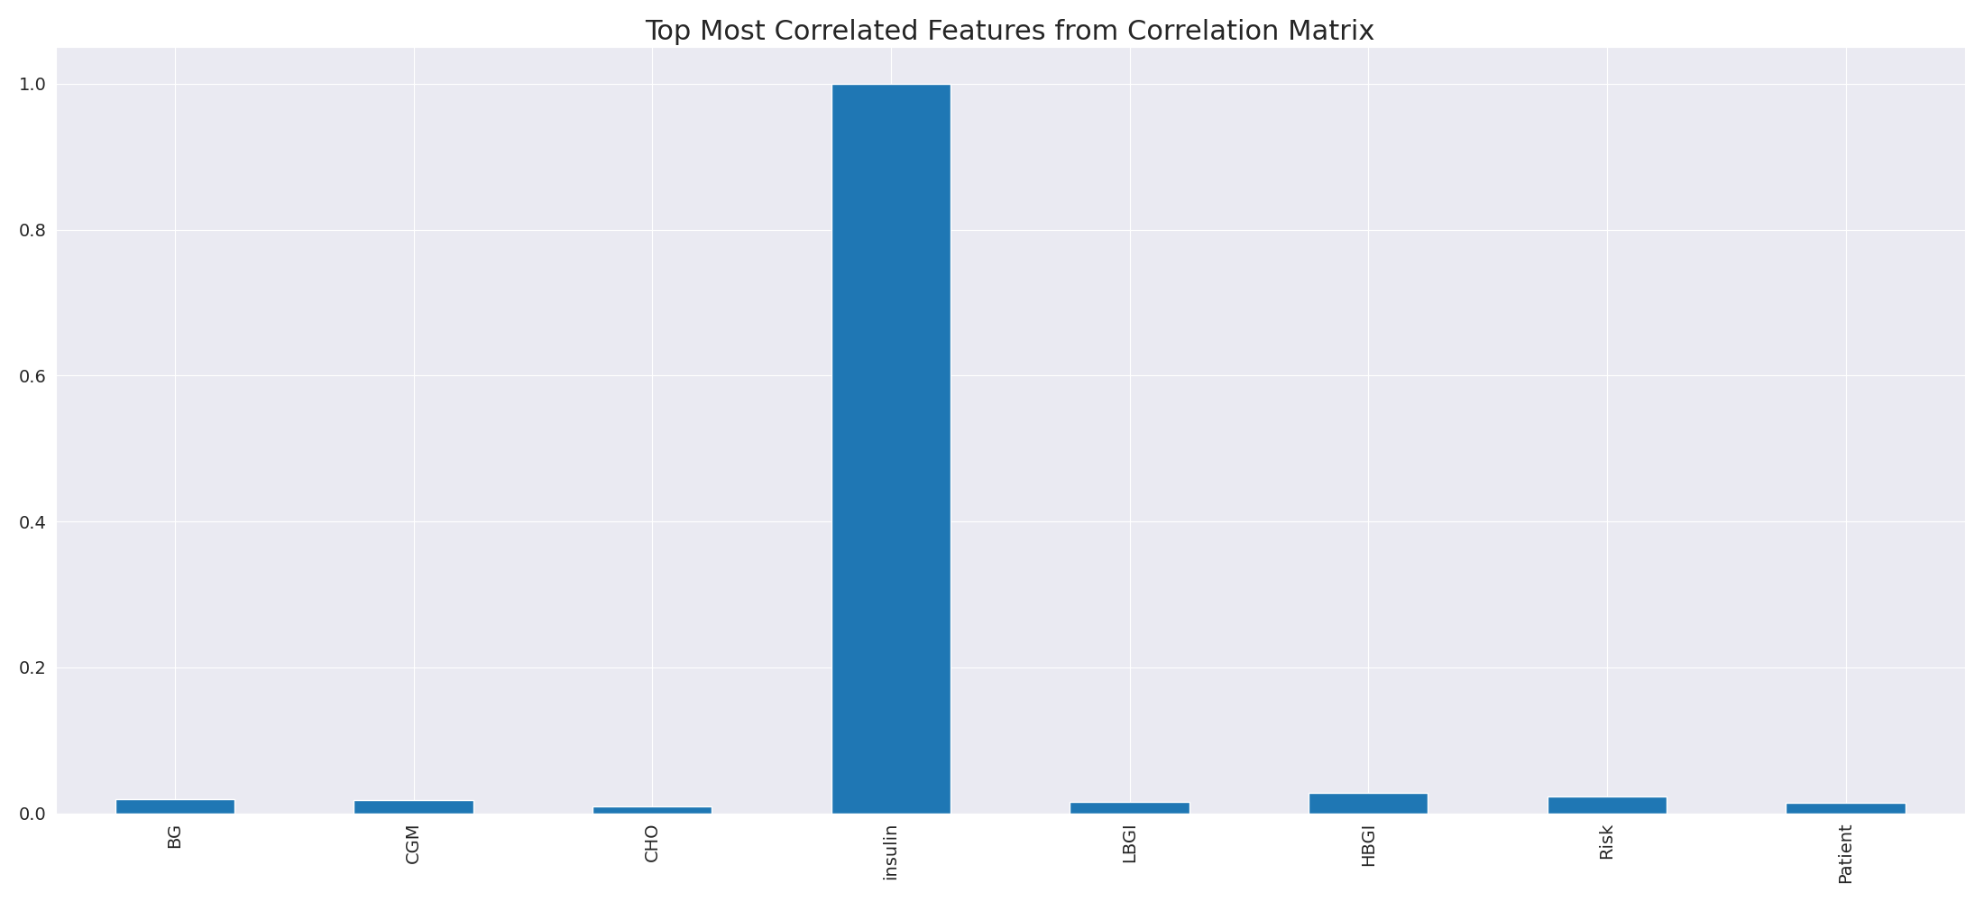

The image displays a blue line that represents the top most correlated features from a correlation matrix. The line is long and extends from the left to the right side of the image. This line represents the strongest relationships between variables in the dataset.  
  
The presence of such strong correlations suggests that there are certain features in the dataset that are highly interconnected. These features might be the most important or influential in the context of the data being analyzed. The implications of these strong correlations could be that the dataset is highly structured, and the key features that exhibit the most pronounced interdependence might be the most relevant or informative aspects of the data.  
  
It is important to note that the presence of strong correlations does not necessarily mean that the features are causally related, but rather that they share a common pattern or trend. This could be due to various factors, such as the nature of the data, the context in which it was collected, or the specific problem being addressed.

Missing Numbers Graph Analysis

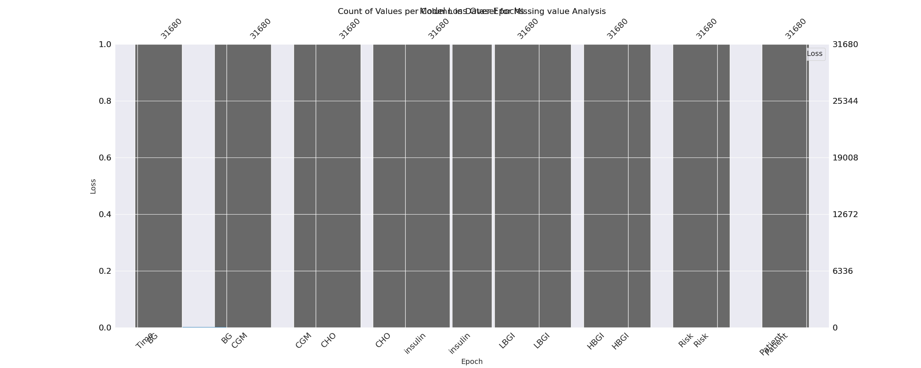

The image displays a graph with a series of numbers, including values and missing values. The numbers are arranged in a line, and the missing values are represented by a blank space. The graph is labeled with the names of the missing values, such as "missing value analysis."  
  
The presence of missing values in the data can impact data analysis or modeling in several ways. It may lead to biased or inaccurate conclusions, as the missing values could be indicative of certain trends or patterns that are not being captured. To address this issue, exploratory data analysis (EDA) techniques can be employed to identify missing values and understand their impact on the data.  
  
EDA techniques involve visualizing the data, looking for patterns, and identifying outliers. By examining the distribution of the data, one can identify the missing values and assess their impact on the overall analysis. For instance, if the missing values are concentrated in a specific region or demographic, it may be necessary to adjust the analysis to account for this bias.  
  
In conclusion, the image highlights the importance of addressing missing values in data analysis and modeling. By employing EDAs, one can better understand the impact of missing values and adjust the analysis accordingly.

Heat_Explainer Graph Analysis

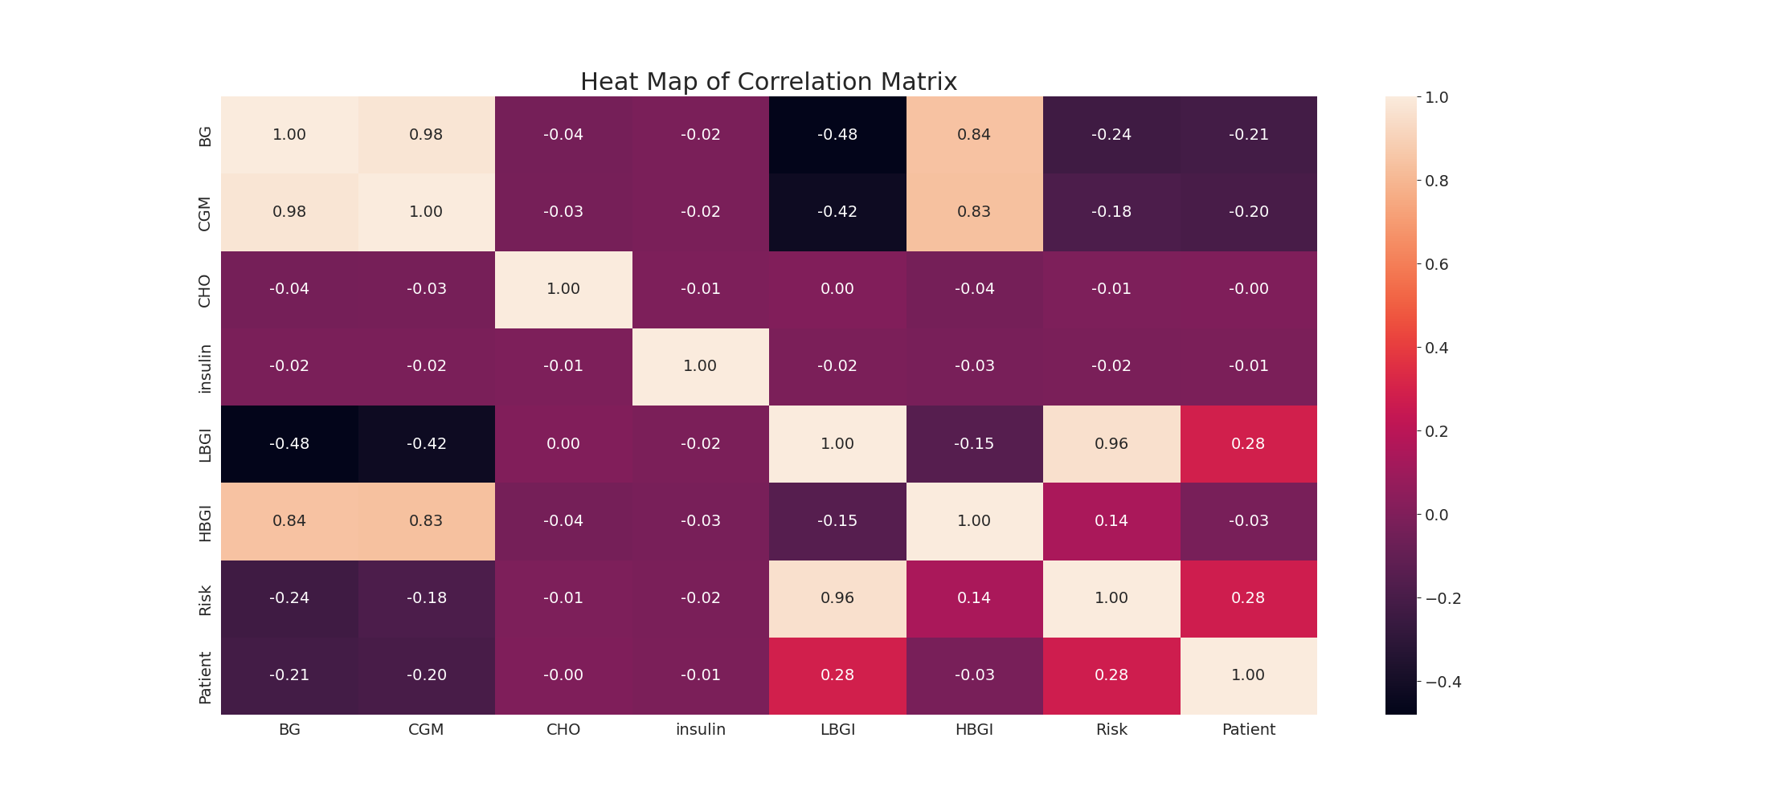

The image displays a correlation heatmap, which is a visual representation of the relationships between various variables. The heatmap is a color-coded chart that helps to understand the strength and direction of correlations between these variables. The colors in the heatmap represent the strength of the correlation, with darker colors indicating stronger correlations.  
  
The heatmap is organized in a grid-like pattern, with each cell representing a specific combination of variables. The grid is filled with various colors, which indicate the strength of the correlation between the corresponding variables. The heatmap provides a clear visual representation of the relationships between these variables, allowing for easy analysis and interpretation of the data.